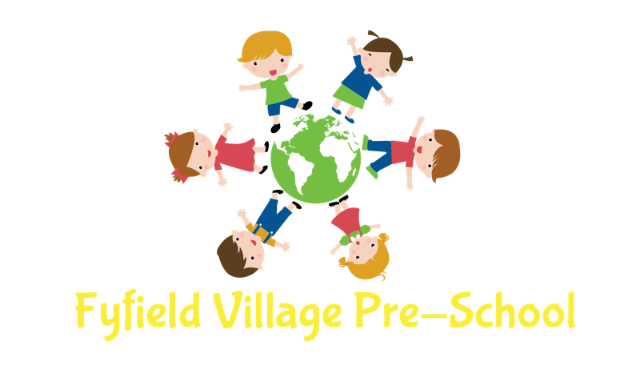
Covid-19 Policy – Updated September 2021

Policy and procedure – Dealing with possible cases of Covid-19

Written in line with current advice from The Department for Education publication
‘Actions for early years and childcare providers during the coronavirus (COVID-19) outbreak’
Available at:
https://www.gov.uk/government/publications/coronavirus-covid-19-early-years-and-childcare-closures/coronavirus-covid-19-early-years-and-childcare-closures
Updated 17th August 2021
and
Contingency framework: education and childcare settings
Available at:
https://assets.publishing.service.gov.uk/government/uploads/system/uploads/attachment_data/file/1011704/20210817_Contingency_Framework_FINAL.pdf
August 2021

To minimise the risk of children attending and staff from contracting coronavirus the following control measures will be in place:
Ensure good hygiene for everyone – provision of tissues and bins, handwashing facilities, ensuring children wash their hands before and after eating and using the toilet. We promote and teach the children to ‘catch it, bin it, kill it’ – Catch a cough/sneeze in a tissue and put it in the bin to kill the germs and then wash their hands. Hand sanitiser is provided for staff, who also follow the above.
Maintain appropriate cleaning regimes – The kitchen, toilets and tables/unit tops to be cleaned by staff before the children arrive. During the day – toilets are cleaned in the morning and afternoon. Tables are cleaned before and after snacks, before and after lunch and at the end of the day. Floors are swept/hoovered and mopped after eating and at the end of the day. All equipment and resources used on that day are sprayed and wiped and are thoroughly cleaned on a 2 weekly basis. Any toys that have been in a child’s mouth will be removed and returned when disinfected. Frequently touched areas such as the cupboards, doorframes etc will be cleaned at least twice a day. The outdoor equipment will be sprayed at the end of the day with disinfectant.
Keep spaces well ventilated – windows are to be kept opened before and after children attend, and during when temperatures allow. When children are outside the door remains open. For safety this is closed at other times such as lunch, group time.
Follow public health advice on testing, self-isolation and managing confirmed cases of COVID-19- Management will keep up to date with any updates and work with different with agencies in the event of a confirmed case of coronavirus in a member staff or child.
In addition to the above staff will carry out Lateral flow home tests twice weekly unless they have symptoms of coronavirus then they will isolate and arrange a PCR test. The lateral flow tests are only suitable for children over 12 years old and adults. They are only to be used if the person taking them has NO symptoms of coronavirus. Anyone with symptoms should arrange a PCR test.
Attendance:
Children or staff are not permitted to attend Pre-school if they present with symptoms of coronavirus as defined by UK government as:
new continuous cough -this means coughing a lot for more than one hour, or 3 or more coughing episodes in 24 hours, and/or
high temperature – defined as 37.8 or above, and/or
loss or change of taste/smell
Anyone experiencing any of the above symptoms will be required to arrange a PCR test, contact the Pre-school as soon as possible and follow the isolation procedure as defined by government:
Available at
https://www.gov.uk/government/publications/covid-19-stay-at-home-guidance/stay-at-home-guidance-for-households-with-possible-coronavirus-covid-19-infection
If a child becomes ill with symptoms whilst at Pre-school the following procedure will be carried out:
The child will be separated from others and looked after by 1 member of staff in the back office. The adult will put on – disposable gloves, a face covering and a disposable apron.
The child’s parents will be contacted and asked to collect their child as soon as possible. Advice will be given to the parent regarding self-isolation and testing procedures. The back office where the child has been will be deep cleaned immediately after the child has left the setting.
The whole of the setting will be deep cleaned at the end of the day in addition to our increased cleaning schedule throughout the remainder of the day.
The staff member will dispose of the apron and gloves and change their clothing.
If a member of staff becomes ill with symptoms whilst at Pre-school the following procedure will be carried out:
The staff member will be asked to collect their belongings and to leave the premises as soon as possible. This may mean a short wait to allow time for management to ensure there are sufficient adults to care safely for the children. In this instance the staff member will be asked to isolate in the back office.
Advice will be given to the member of staff regarding self-isolation and testing procedures. The area where the staff member has been waiting will be deep cleaned immediately after the staff member has left the setting.
The whole of the setting will be deep cleaned at the end of the day in addition to our increased cleaning schedule throughout the remainder of the day.
To ensure the safety of all children and staff we are requiring anyone who has symptoms to arrange a PCR for Covid-19.
To access testing please go to:
https://www.gov.uk/get-coronavirus-test

If the child or member of staff tests negative to the PCR test they can resume coming to Pre-school as long as they are well within themselves.
If a child or staff member has tested positive, we are requesting confirmation of the results so that we can keep a record in the event of any further cases.
If the child or member of staff tests Positive to the PCR test they must follow government guidelines of isolating and must not attend Pre-school.
We are required to notify Ofsted (Office for standards in education) of any positive cases of coronavirus from either staff or children.
Advice on isolation periods can be found here:
https://www.gov.uk/government/publications/covid-19-stay-at-home-guidance/stay-at-home-guidance-for-households-with-possible-coronavirus-covid-19-infection
If we have several confirmed cases within 10 days, this may be deemed as an outbreak defined by the Department for Education as whichever of these thresholds are reached first:
5 children, pupils, students or staff, who are likely to have mixed closely, test positive for COVID-19 within a 10-day period; or
10% of children, pupils, students or staff who are likely to have mixed closely test positive for COVID-19 within a 10-day period
There are currently 50 children on the register and 10 staff – total 60 – 10 % would be 6 – so we will therefore operate our outbreak plan if there are 5 or more staff and children combined who test positive via a PCR test within 10 days.

We follow our ‘Outbreak’ plan as follows:
In the event of the above thresholds being reached (confirmed by PCR tests) we will review and reinforce our existing testing, ventilation and hygiene measures. This may include but is not limited to the re-introduction of face coverings when dropping off/collecting children, increased lateral flow testing for staff and parents of children, spending more time outdoors, increased supervision on handwashing, removal of equipment that cannot be cleaned easily e.g. fabrics, cushions.
Additional public health advice will be sought by contacting the Department of education helpline (0800 046 8687, option 1)

Staffing
If the outbreak is because of staff testing positive with a PCR test, the manager will look at the number of staff required for each session – morning and afternoon. If there are enough remaining staff, that are not affected, to meet the adult to child ratios then the Pre-school will operate as normal. If there are not enough staff to safely care for the children then the manager will contact all families to offer alternative session where there is enough staff. If we did have to limit the amount of children able to attend Pre-school we would prioritise vulnerable children and children of key workers.

Children
If the outbreak is amongst children in the setting we will work closely with all of the relevant authorities and be advised by them. In the first instance a deep clean of the setting will take place. All parents will be notified of confirmed cases. No names will be given. All staff will book and undertake a PCR test. Staff that are double vaccinated will not be required to isolate but will be encouraged to limit social contact as much as possible whilst awaiting the results of the PCR test.
Children who are aged under 5 years old who are identified as close contacts will only be advised to take a PCR test if they develop symptoms or there is a positive case of coronavirus in their household.
Community
If we are advised of an increased amount of coronavirus cases within the community we will be advised by the local health protection authority.
Isolation
Current government advice is that children under 18 years old and adults that have been double vaccinated do not need to isolate if they have been in contact with a person who has tested positive for coronavirus. This would mean that if a child/ staff member at Pre-school tested positive for coronavirus, the other children as they are under 18 and staff ( those who are double vaccinated) do not have to isolate and we will not have to close as we did previously. All families will be notified of any case of coronavirus.
If someone in your household has tested positive for coronavirus, we ask that the person who has tested positive and anyone over the age of 18 who has not been double vaccinated do not come to the Pre-school, as they should be isolating. Although children under 18 do not have to isolate, they are more likely to become infected due to living with an infected person who provides care for them.
We would therefore like to request that the child/children take a PCR test before returning to Pre-school. Once they have received a negative result they can return but can only be dropped off and collected by an adult that is not meant to be self-isolating. If you are over 18 and have not been double vaccinated you would be required to self-isolate and cannot come to Pre-school to drop off or collect.

